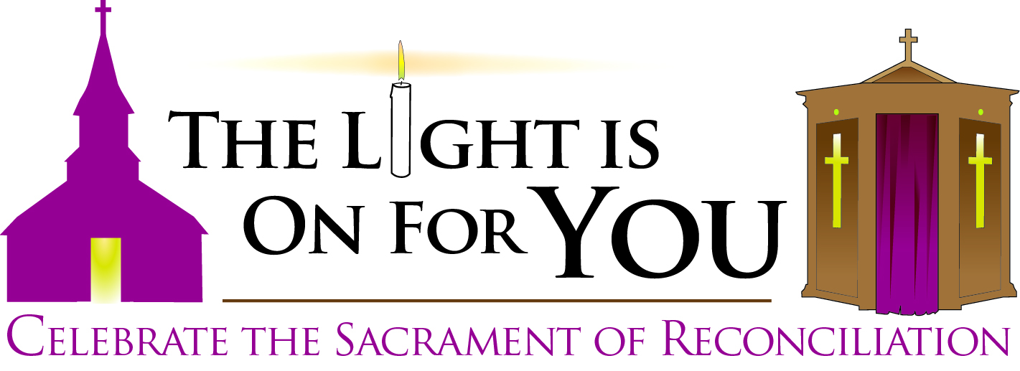

**Possible Prayers of the Faithful**

**General**

That Catholics in our Archdiocese will heed the Lord’s Lenten call to repentance and take advantage of the upcoming Archdiocesan celebration of Reconciliation, *The Light Is On For You*, to receive His forgiveness in the Sacrament of Penance. ***We pray to the Lord.***

That those Catholics who have fallen away from the regular practice of the faith will take advantage of the upcoming Archdiocesan celebration of Reconciliation, *The Light Is On For You*, to receive the Lord’s loving mercy and begin again. ***We pray to the Lord.***

**Specific**

**February 10**

That Catholics who have been away from the practice of the Sacrament of Confession will take advantage of the upcoming Archdiocesan celebration of Reconciliation, *The Light Is On For You*, to come to be reconciled to God. ***We pray to the Lord.***

**February 17**

That all those who have succumbed to temptation to sin will come and receive Jesus’ loving mercy during the special Archdiocesan celebration of Reconciliation, *The Light Is On For You*, Wednesday nights during Lent. ***We pray to the Lord.***

**February 24**

That all of us will heed God the Father’s command to listen to his Son and act on his call to repentance this Lenten season by making a good confession during the special Archdiocesan celebration of Reconciliation, *The Light Is On For You*, Wednesday nights during Lent. ***We pray to the Lord.***

**March 03**

That each of us will heed Jesus’ call to repentance by making a good confession during the Archdiocesan celebration of Reconciliation, *The Light Is On For You*, so that we may share in the kingdom of heaven.

***We pray to the Lord.***

**March 10**

That all of us, like the younger son, will approach God the Father in repentance for our sins during our Archdiocesan celebration of Reconciliation, *The Light Is On For You*. ***We pray to the Lord.***

**March 17**

That each of us will return to the Lord with a whole heart, making a good confession during the Archdiocesan celebration of Reconciliation, *The Light Is On For You*, for He is gracious and merciful.

***We pray to the Lord.***

**March 24**

In gratitude to God for all the graces He has given to Catholics throughout our Archdiocese during the special celebration of Reconciliation, *The Light Is On For You*. ***We pray to the Lord.***