EIGHTH COMMANDMENT
"You shall not bear false witness against your neighbor." (Ex 20:16)

- Did I lie? Have my lies caused spiritual or material harm to others?
- Have I told lies about anybody (calumny)?
- Have I injured others by revealing true hidden faults (detraction)?
- Did I commit perjury? Have I been guilty of refusing to testify to the innocence of another because of fear or selfishness?
- Have I engaged in uncharitable talk or gossip?
- Have I encouraged the spread of scandal?
- Am I guilty of any type of fraud?
- Did I insult or tease others with the intention of hurting them?
- Have I falsely flattered others?
- Have I made rash judgments about others?
- Did I fail to keep secret what should be confidential?

OTHER SINS
- Did I intentionally refuse to mention some grave sin in my previous confessions?
- Have I fulfilled my obligation to go to confession at least once a year and of going worthily to Holy Communion at least during the Easter season?
- Did I fast on Ash Wednesday and Good Friday?
- Did I abstain from meat on the Fridays of Lent or Ash Wednesday?

Please note: Priests must be given faculties explicitly by their bishop to absolve the sin of abortion. Cardinal Seán O'Malley has granted these faculties to all priests in the Archdiocese of Boston.

These materials have been adapted from the Diocese of Fall River’s “Be Reconciled to God” Initiative in 2009, with permission of Fr. Roger Landry.

Going to Confession
The penitent and the priest begin with the sign of the Cross, saying:
In the Name of the Father and of the Son and of the Holy Spirit.

The priest urges the penitent to have confidence in God with these or similar words:
May the Lord be in your heart and help you to confess your sins with true sorrow.

The priest may read or say a passage from Sacred Scripture after which the penitent then states:
Forgive me, Father, for I have sinned. It has been (however many days, weeks, months or years) since my last confession.

The penitent then states his or her sins. For the confession to be valid, the penitent must confess all of the mortal sins he or she is aware of having committed since the last confession, be sorry for them, and have a firm purpose of amendment to try not to commit the same sins in the future.

After this, the priest will generally give some advice to the penitent and impose a penance. Then he will ask the penitent to make an act of contrition. The penitent may do so in his or her own words, or may say one of many memorized acts of contrition like the following:

Act of Contrition
O My God, I am sorry for my sins with all my heart. In choosing to do wrong and failing to do good, I have sinned against you, whom I should love above all things. I firmly intend, with the help of your grace, to do penance, to sin no more and to avoid whatever leads me to sin. Our Savior, Jesus Christ, suffered and died for us. In His Name, O Lord, have mercy.

After this the priest will absolve the penitent in the following words:
God, the Father of mercies, through the death and resurrection of his Son has reconciled the world to himself and sent the Holy Spirit among us for the forgiveness of sins; through the ministry of the Church may God give you pardon and peace, and I absolve you from your sins in the name of the Father, and of the Son + and of the Holy Spirit.

The penitent makes the sign of the Cross and answers: Amen

The priest will then dismiss the penitent with a short prayer and encouragement. The penitent should then immediately try to fulfill the penance imposed if it is something that can be done quickly.

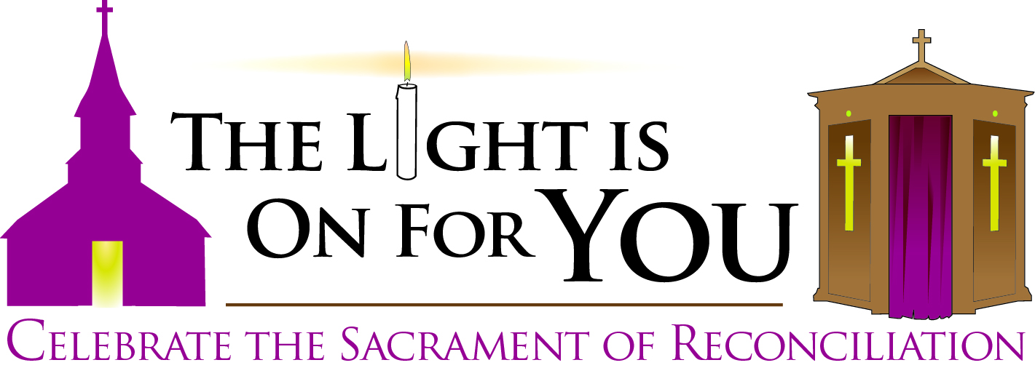

A Guide to Making a Thorough Examination of Conscience and
a Good Confession

Preparing for the Sacrament of Penance
Ask God the Holy Spirit’s help to examine your conscience well by prayerfully reviewing your conduct in light of the commandments and the example of Christ. The questions below should assist you in making a thorough review.

Tell the priest the specific kind of sins you have committed and, to the best of your ability, how many times you have committed them since your last good confession. Avoid generalizations and inform the priest of any relevant circumstances in which your sins were committed.

You are obliged to confess only mortal sins, since you can obtain forgiveness for your venial sins by sacrifices, acts of charity, prayer and other pious actions. Confession of venial sins, however, is very helpful for avoiding sin and advancing in holiness toward Heaven.

If you are in doubt about whether a sin is mortal or venial, mention your doubt to the priest. For a sin to be mortal, three conditions must together be met: “Mortal sin is sin whose object is grave matter and which is also committed with full knowledge and deliberate consent.” (CCC 1857)

Always tell the priest your state of life: married or single, priest or religious, under religious vows or promises.

Examination of Conscience
Catholics for centuries have found it profitable to examine their consciences in light of the Ten Commandments. Penitents are encouraged to expand on them in their prayerful review of their conduct.

FIRST COMMANDMENT
"I am the Lord your God. You shall not have strange gods before Me." (Ex 20:2,3)

- Have I really loved God above all things or have I put other things — work, money, drugs, TV, fame, pleasure, other people — ahead of Him?
- Have I made time for God each day in prayer?
- Have I denied my faith in God or endangered it by practices of the occult or through reading or programs that are opposed to faith and morals?
- Am I whole-hearted in accepting and following God’s teaching or do I only pick and choose the convenient parts of His message? Have I tried to learn and understand my faith better?
- Have I denied my faith before others? Have I been willing to affirm, defend and practice my faith in public and not just in private?
- Did I despair of or presume on God's mercy?

SECOND COMMANDMENT
"You shall not take the Name of the Lord your God in vain." (Ex 20:7)

- Do I love and have reverence for God’s Name?
- Have I offended God by blasphemy, cursing, or treating his name carelessly?
- Do I try my best to fulfill the promises and resolutions that I have made toward God, especially those of my Baptism and Confirmation?
- Have I shown disrespect for the Blessed Virgin Mary, the saints, the Church, holy things or holy people?

THIRD COMMANDMENT
"Remember to keep holy the Sabbath Day." (Ex 20:8)

- Did I miss Mass on Sunday or a Holy Day of Obligation through my own fault?
- Have I fully, consciously and actively participated in Holy Mass or just gone through the motions?
- Have I given my full attention to the Word of God or have I given in easily to distractions?
- Have I arrived at Mass late due to carelessness?
- Have I left early without a serious reason?
- Have I kept the Eucharistic fast before Holy Mass?
- Have I received Holy Communion in a state of mortal sin?
- Did I do work on Sunday that was not necessary?
- Have I used Sunday as part of the “weekend” or as a day for acts of love toward God, my family & those in need?

FOURTH COMMANDMENT
"Honor your father and your mother." (Ex 20:12)

- Did I neglect my duties to my husband, wife, children, parents or siblings?
- Have I failed to be grateful for the sacrifices my parents have made for me?
- Have I disrespected my family members, treated them with scant affection, or reacted proudly when corrected by them?
- Did I cause tension and fights in my family?
- Have I cared for my aged and infirm relatives?
- Have I provided for the Christian education of my children through Catholic school or religious instruction? Do I inspire them by my virtue or scandalize them by my failings?
- When I have disciplined my children, did I do so with charity and prudence?
- Have I encouraged my children to pray about their why God created them, and whether God may be calling them to the priesthood or religious life?

FIFTH COMMANDMENT
"You shall not kill." (Ex 20:13)

- Did I kill or try to physically harm someone?
- Did I attempt suicide or entertain thoughts of taking my life?
- Did I have an abortion, or encourage or help someone else to have one? Have I participated in the practice of abortion through my silence, financial support for persons or organizations that promote it, or voting without a very serious reason for candidates who support it?
- Have I taken part in, or supported, so-called "mercy killing" (euthanasia)?
- Have I abused my children or others in any way?
- Have I mutilated or harmed my body?
- Have I borne hatred or withheld forgiveness?
- Have I been reckless behind the wheel so as to put my and others’ lives in danger?
- Have I neglected my health?
- Did I give bad example through drug abuse, drinking alcohol to excess, fighting, or quarreling?
- Have I easily gotten angry or lost my temper?

SIXTH & NINTH COMMANDMENTS
"You shall not commit adultery." (Ex 20:14)
"You shall not covet your neighbor's wife." (Ex 20:17)

- Have I remembered that my body is a temple of the Holy Spirit?
- Did I willfully entertain impure thoughts or desires?
- Did I deliberately look at impure TV programs, computer sites, videos, pictures, or movies?
- Did I commit impure acts with myself (masturbation) or with others through adultery (sex with a married person), fornication (premarital sex) or homosexual activity?
- Have I been faithful to my husband or wife in my heart and in my conduct with others?
- Have I sinned through the use of contraception, contraceptive sterilization, or in-vitro fertilization?
- Have I touched or kissed another person in a lustful way? Have I treated others, in my deeds or thoughts, as objects?
- Have I been an occasion of sin for others by acting or dressing immodestly?
- Am I married according to the laws of the Church?
- Did I advise or encourage anyone to marry outside the Church?

SEVENTH & TENTH COMMANDMENTS
"You shall not steal." (Ex 20:15)
"You shall not covet your neighbor's goods." (Ex 20:17)

- Have I been greedy or envious?
- Have I made acquiring material possessions the focus of my life? Am I inordinately attached to the things of this world?
- Did I steal, cheat, help or encourage others to steal or to keep stolen goods? Did I receive stolen goods? Have I returned or made restitution for things I have stolen?
- Did I damage others’ property without acknowledging it and repairing it?
- Have I paid my debts or have I played the system so as to avoid fulfilling my obligations?
- Have I cheated my company? Have I given a full day’s work for a full day’s pay? Have I paid a fair wage to anyone who works for me? Have I been faithful to my promises and contracts? Have I given or accepted bribes?
- Have I allowed work to get in the way of my obligations to God or to my family?
- Do I generously share my goods with the needy?
- Am I generous to the work of the Church? Do I share my time, talents and treasure in the apostolic and charitable works of the Church and in the life of my parish?

