Please Come
to the Sacrament of Reconciliation this Lent

The Church encourages all Catholics to celebrate the Sacrament of Reconciliation each Lent.  In addition to our normal Saturday afternoon confession time, our parish and all the Catholic parishes and chapels of the Archdiocese will be open on Lenten Wednesdays from 6:30-8:00pm. Please take advantage of this opportunity to make a good Lenten confession. | 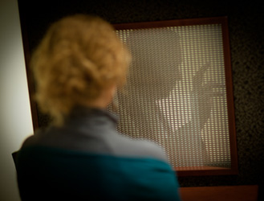
Please also reach out to the Catholics you know that have been away from the regular practice of our faith and invite them to seize this chance to begin again.

The Archdiocese’s website for this initiative, www.TheLightIsOnForYou.org, has great material to help everyone prepare to make a good confession.

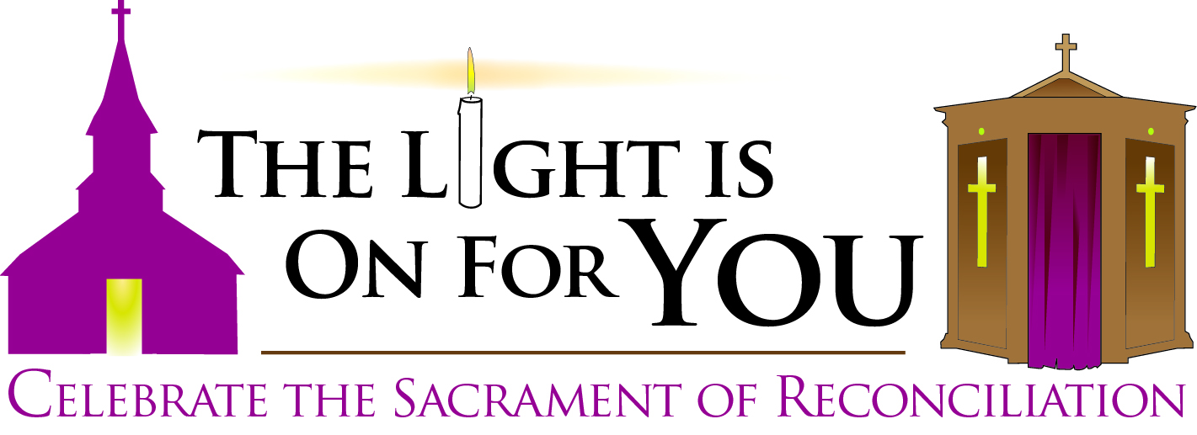

Every Parish and Chapel
of the Archdiocese of Boston
Wednesdays in Lent
6:30-8:00pm
February 20 and 27, March 6, 13, 20 and 27

Please visit www.TheLightIsOnForYou.org for more information

