You are Invited
Please come and experience Christ’s Healing & Saving Love

On Wednesday from 6:30-8:00pm, and on all Wednesdays in Lent, we will be offering confessions here at our parish, together with all the Catholic parishes and chapels in the Archdiocese of Boston.  This outreach is called The Light is On For You, and is an effort on the part of our Archdiocese to highlight the importance of the sacrament of confession in the life of Catholics and to make it as easy as possible for every Catholic to come or to return to this great source of God’s mercy and healing love. | 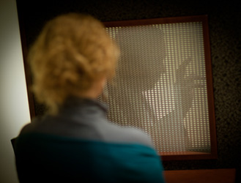
You are welcome to come here or to go to any other Catholic parish or chapel.

The Archdiocese has set up a website, www.TheLightIsOnForYou.org, with lots of great material and videos to help you prepare. Please make plans to come yourself and please invite others take advantage of this great opportunity to be reconciled and begin anew your journey in faith this Lent.

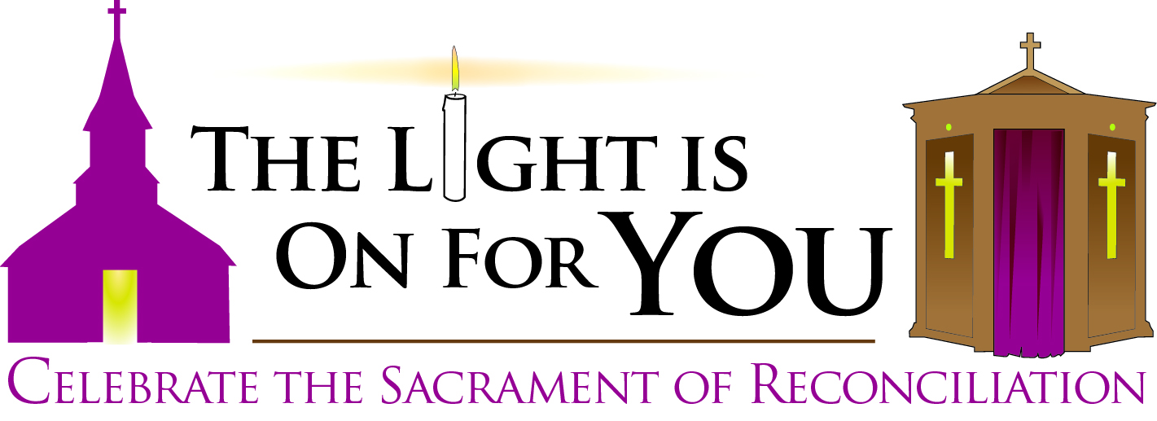

Every Parish and Chapel
of the Archdiocese of Boston
Wednesdays in Lent
6:30-8:00pm
February 20 and 27, March 6, 13, 20 and 27

Please visit www.TheLightIsOnForYou.org for more information

