You are Invited
Please come and experience Christ’s Healing & Saving Love

Our parish and all the parishes and chapels of the Archdiocese of Boston will be open for individual confessions on all the Wednesday’s of Lent from 6:30-8:00pm. | 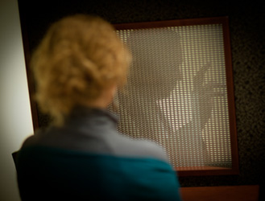
The Archdiocese has set up a website, www.TheLightIsOnForYou.org, to help you prepare. It has videos on the Sacrament of Reconciliation, sheets on how to make a good confession, answers to frequently-asked questions and more.

Please make plans to come on Lenten Wednesdays and spread the word of this special outreach of mercy to those you know.

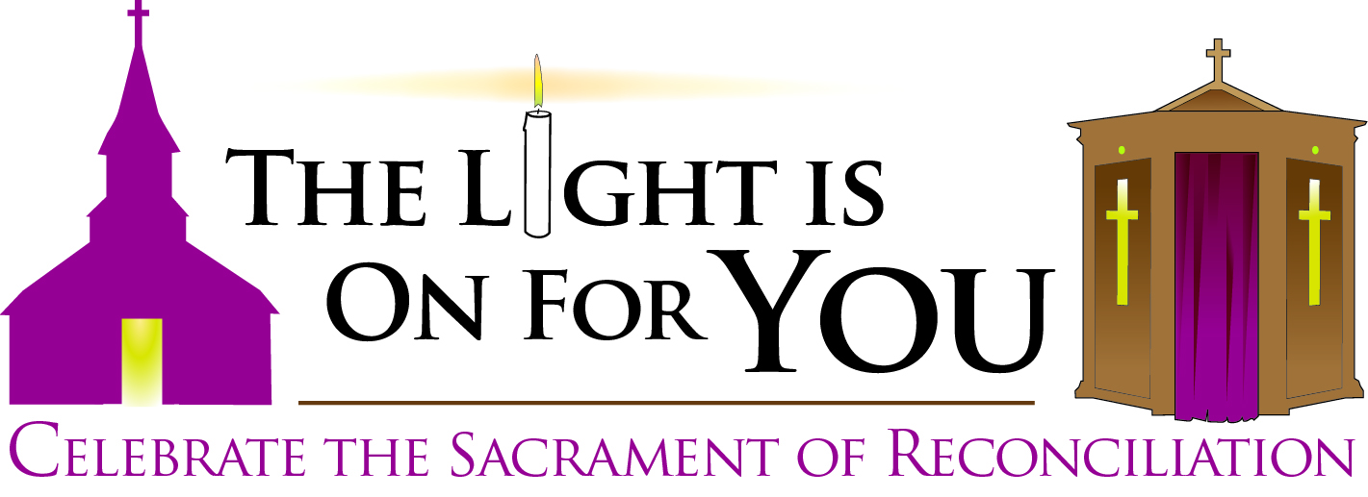

Every Parish and Chapel
of the Archdiocese of Boston
Wednesdays in Lent
6:30-8:00pm
February 20 and 27, March 6, 13, 20 and 27

Please visit www.TheLightIsOnForYou.org for more information

