|  |
| --- |
| ***You are Invited***  *Please come and experience Christ’s Healing & Saving Love*  *in the Sacrament of Reconciliation* |

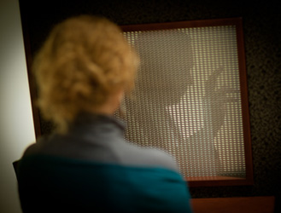

|  |
| --- |
| *TheLightIsOnForYou logo 2010-01-19.jpg* |
| **Every Parish and Chapel**  **of the Archdiocese of Boston** |
| **Wednesdays in Lent**  **6:30-8:00pm**  **February 20 and 27, March 6, 13, 20 and 27** |

*Please visit* [*www.TheLightIsOnForYou.org*](http://www.TheLightIsOnForYou.org) *for more information*